Góc trái đặt logo 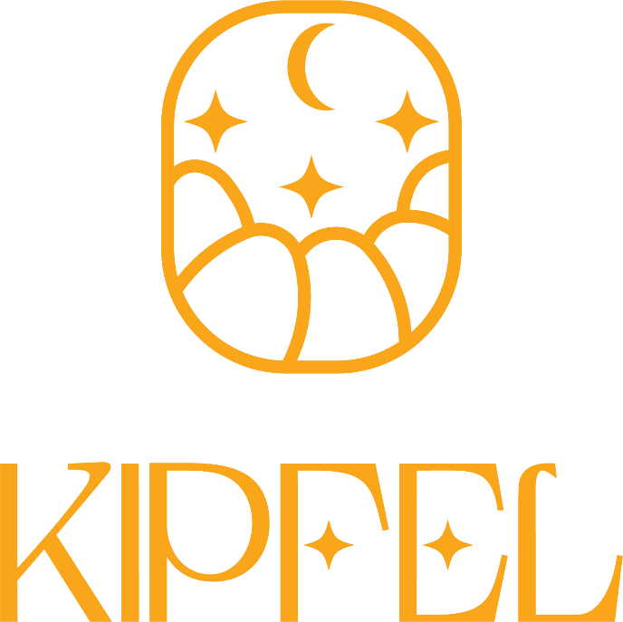

Những màu đen trên web chuyển thành màu xanh đen 202e3a

Màu trắng trên web chuyển thành màu kem f0e0ca

Màu vàng cam thành màu vàng logo faa61a

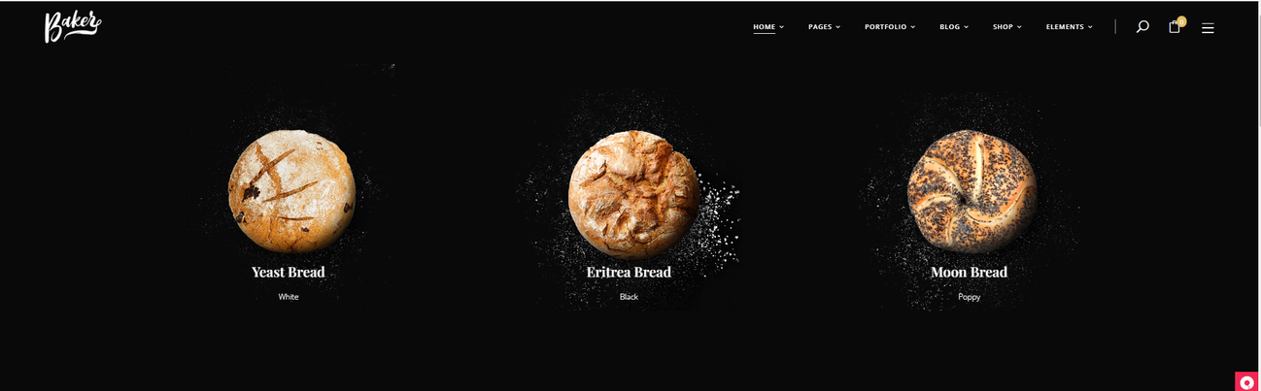

Hình trên đầu này để hình này

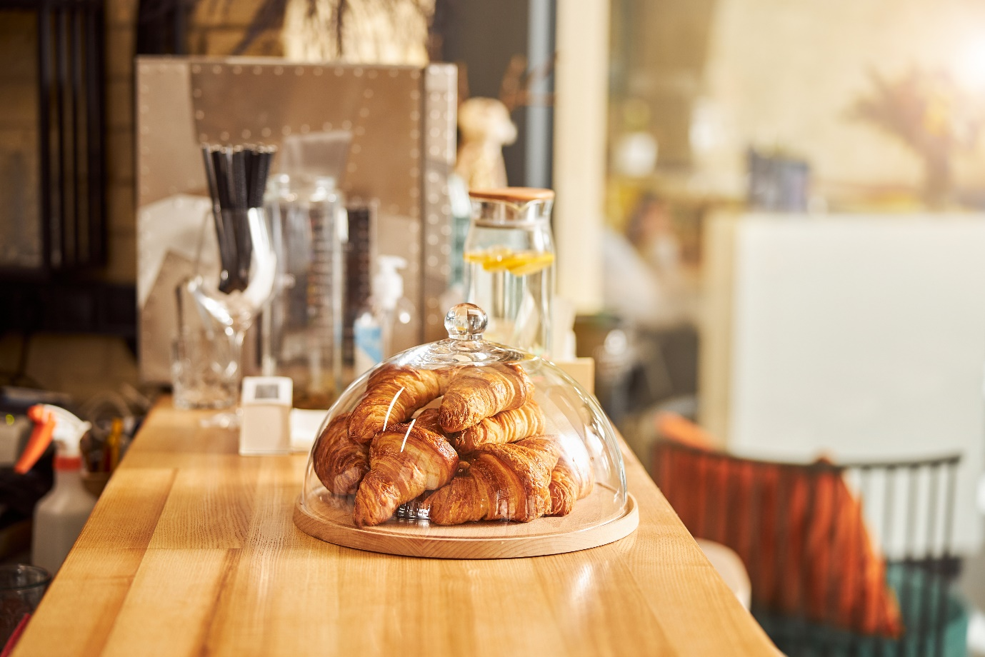

Trang about us

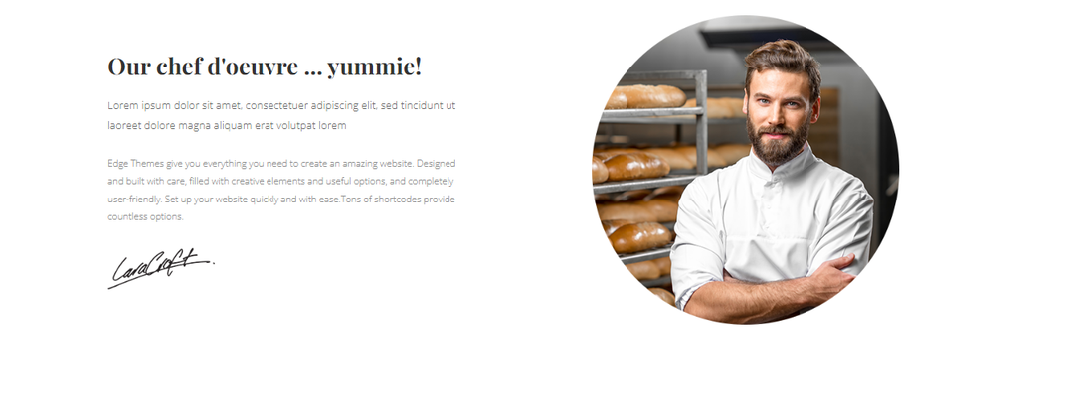

Kipfel was chosen as our croissant brand name. The name Kipfel is taken from the early history of the cake before it was called a croissant. Inspired by delicious croissants and crescent moons - a symbol of the beginning of rebirth and a symbol of dreams come true. We have created a logo with flexible color changeable brushstrokes on different color backgrounds. Show high adaptability everywhere so that our brand is known to the world.

The logo is chosen in yellow-orange - showing confidence and always full of energy ready to work, ready to face challenges.

After years of research and learning, we will bring you croissants with our own recipe that combines traditional and modern flavors.

With the slogan "Baked fresh, just for you" - Kipfel's open kitchen counter will bring you a delicious baked croissant just for you every day.

"A little bliss in every bite."

Bên trái hình 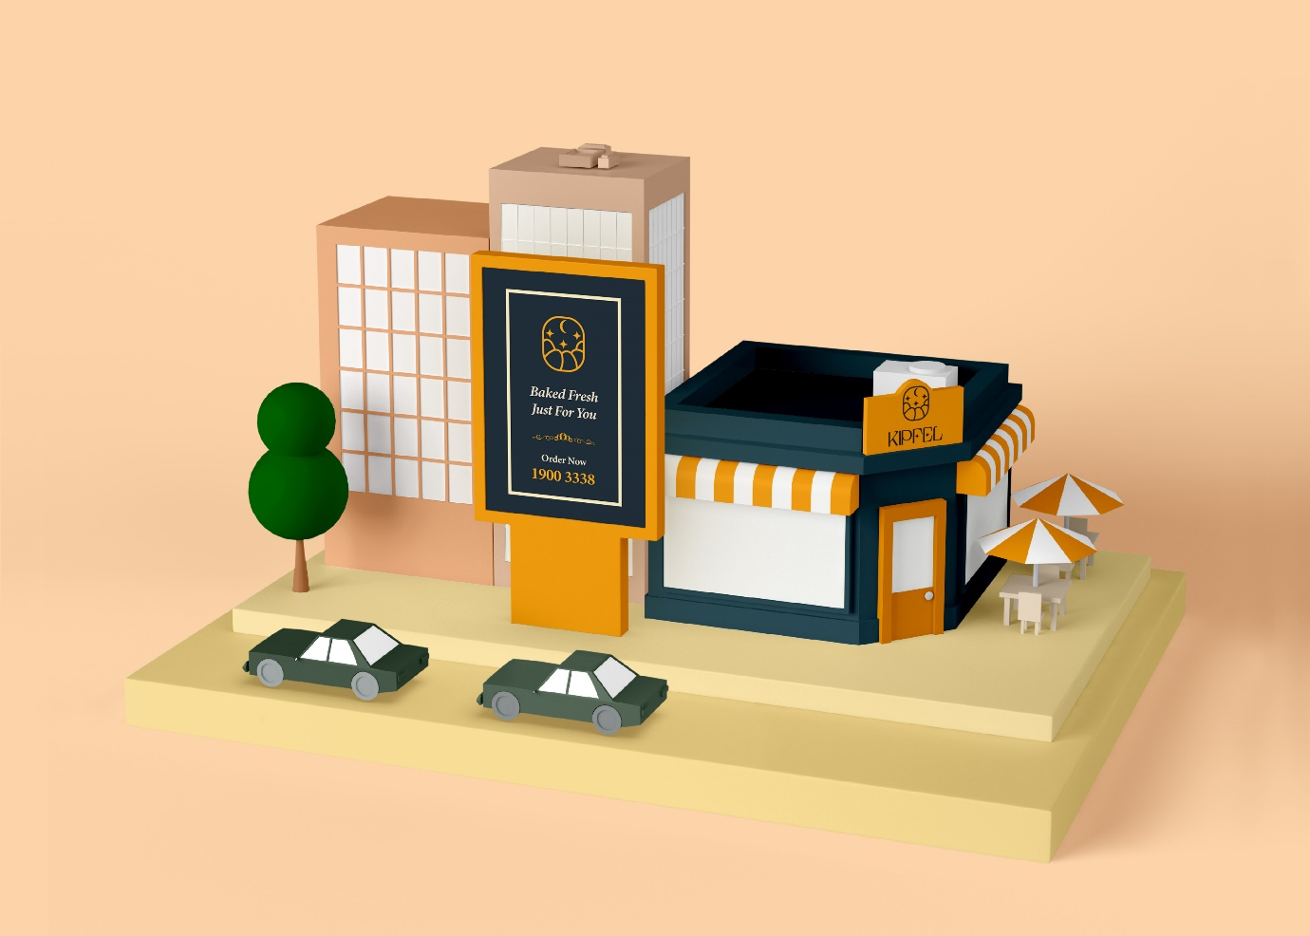

Trang này 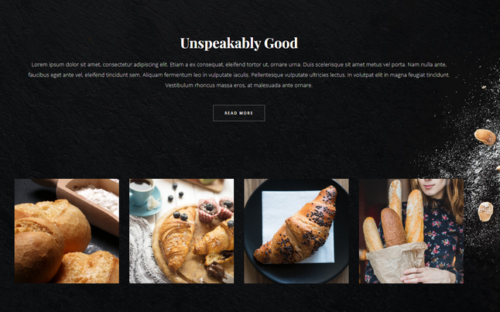

Đổi nội dung thành hình 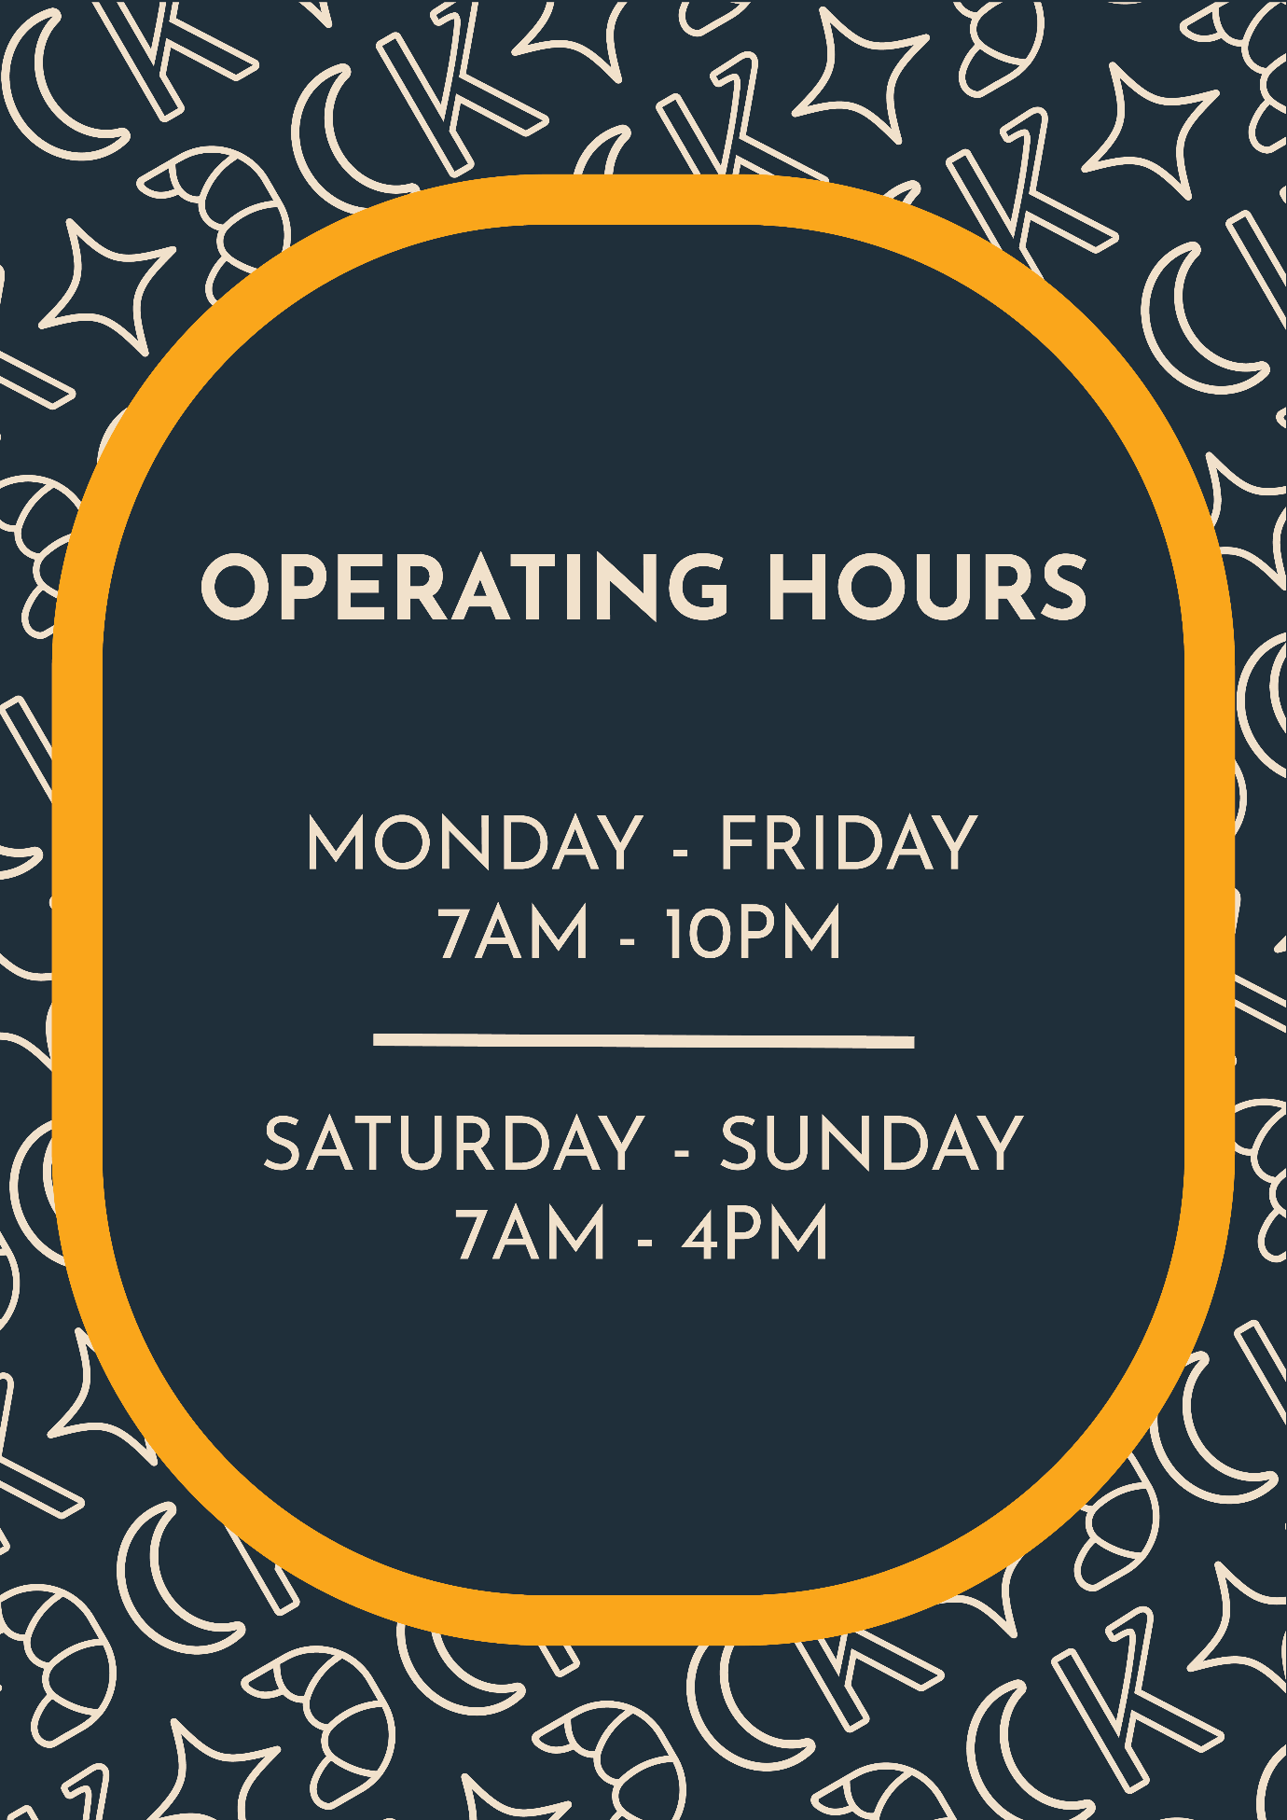

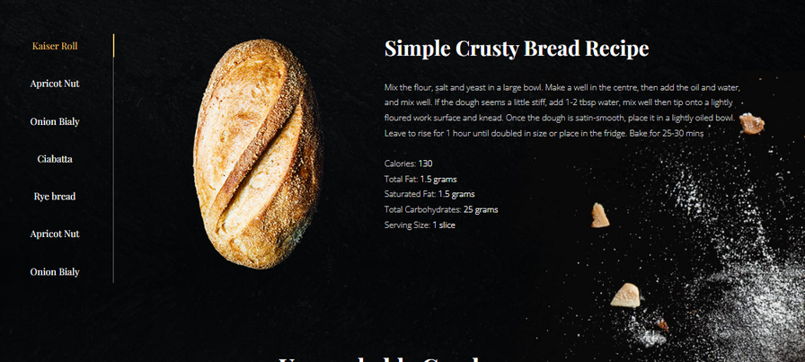

Thay hình này bằng hình sau: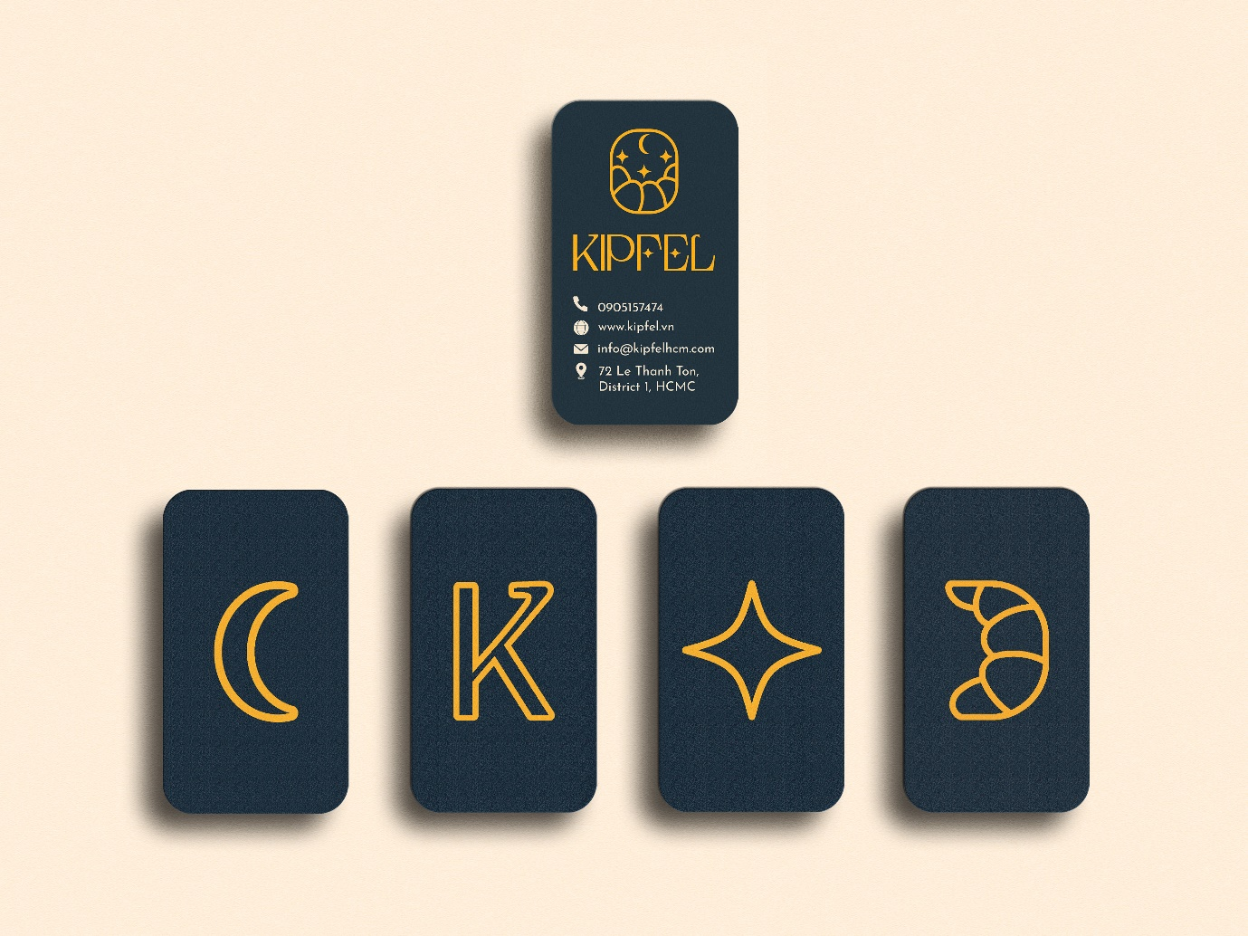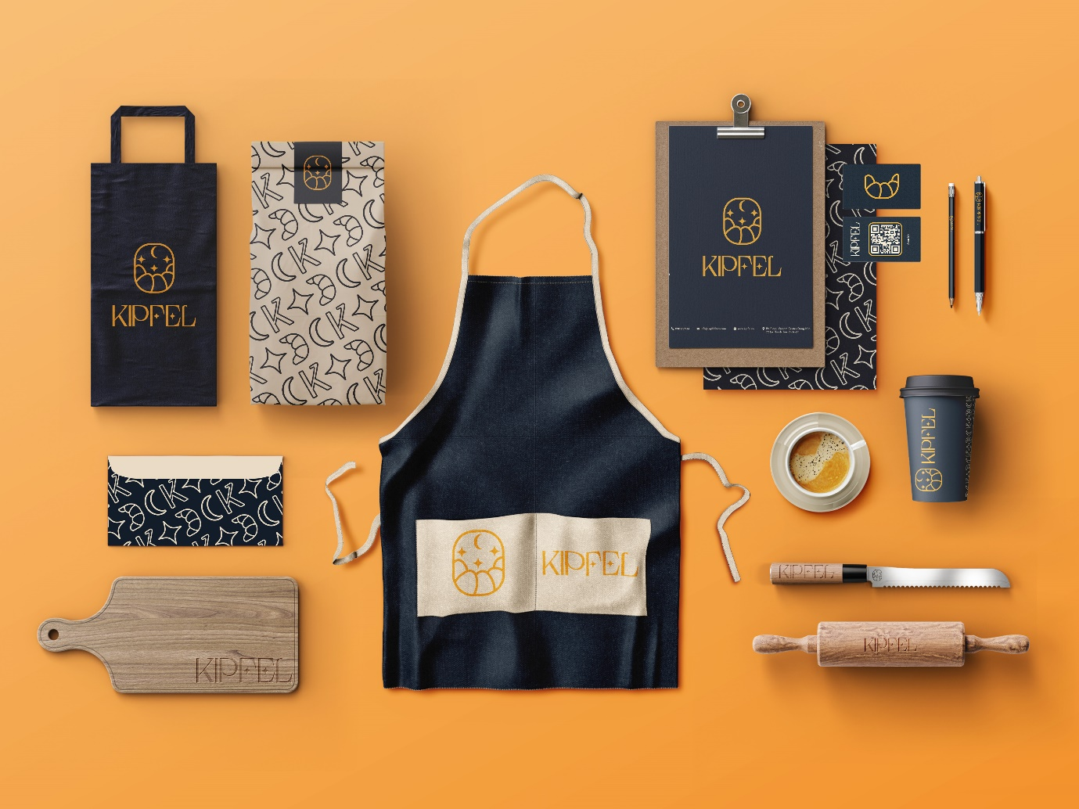

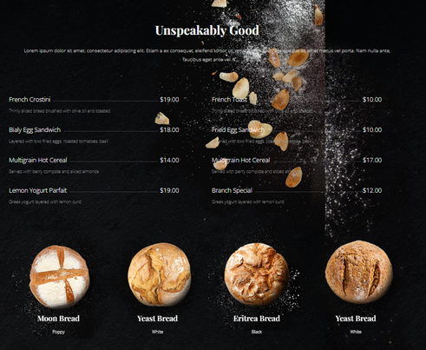

Trang menu

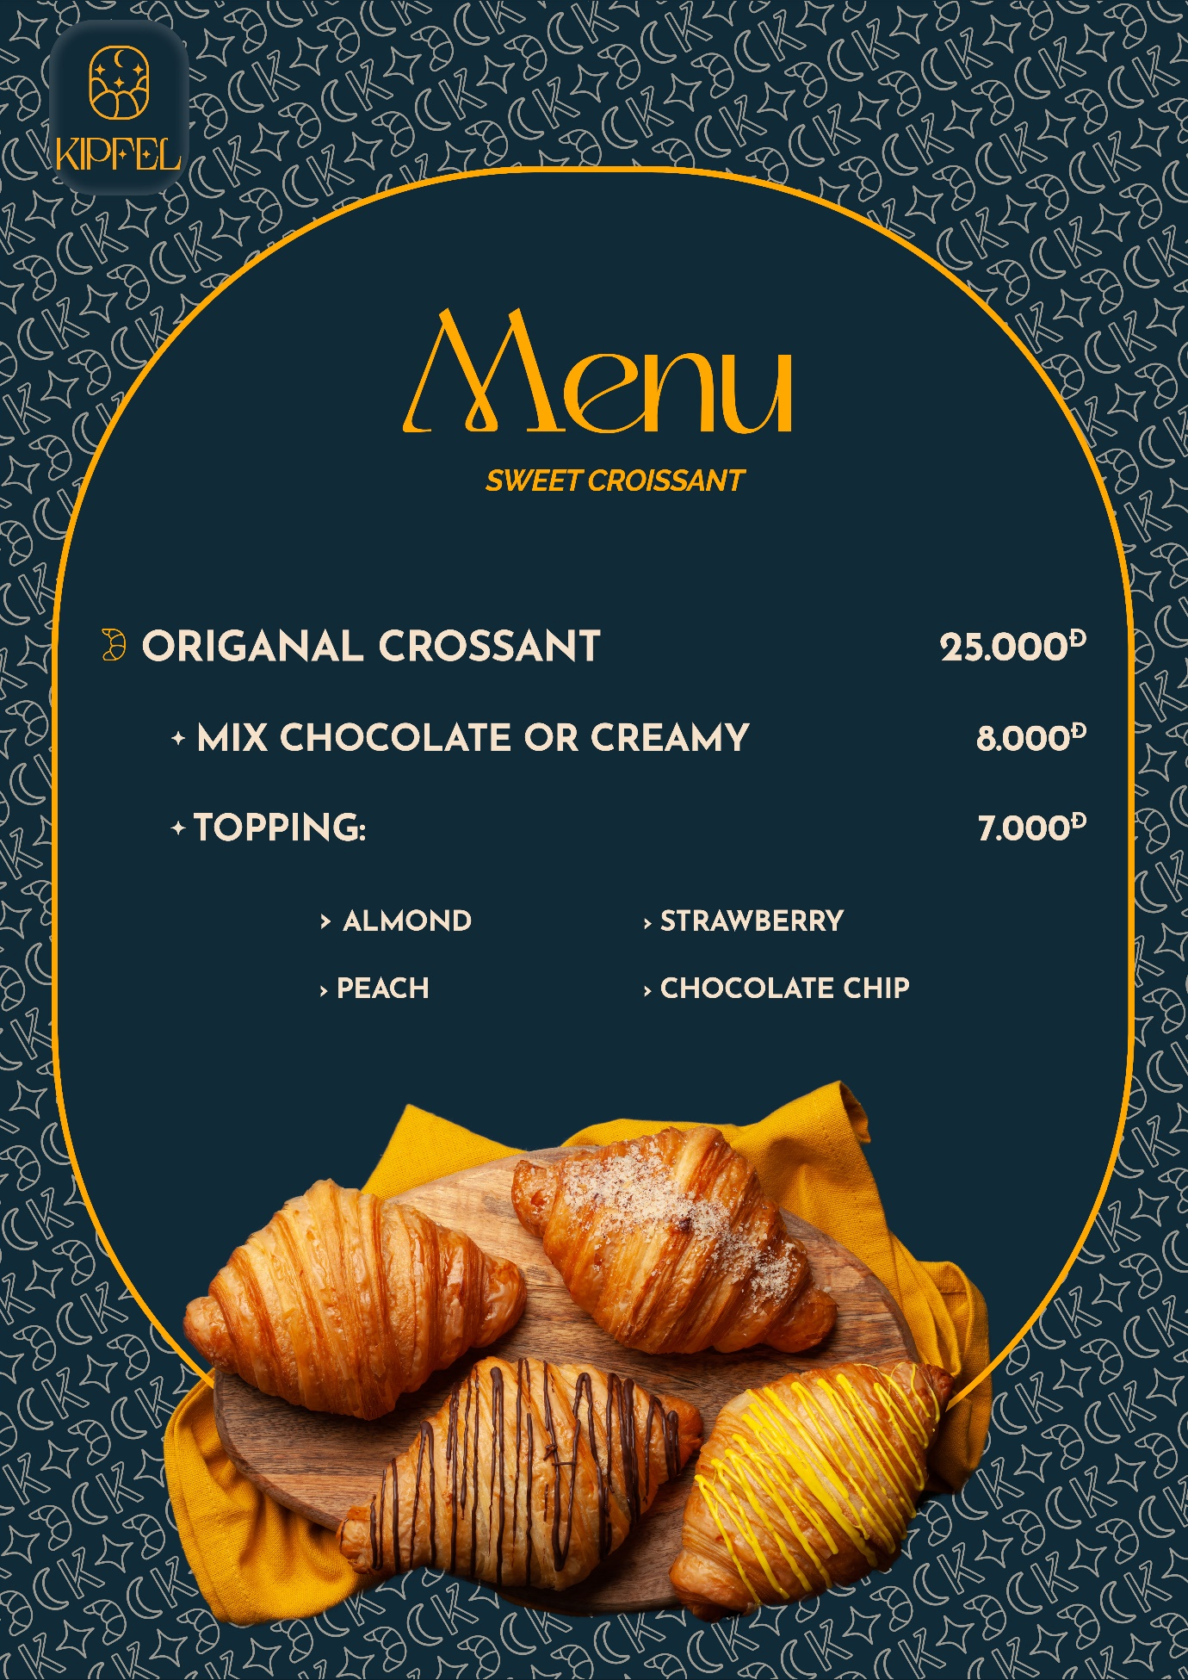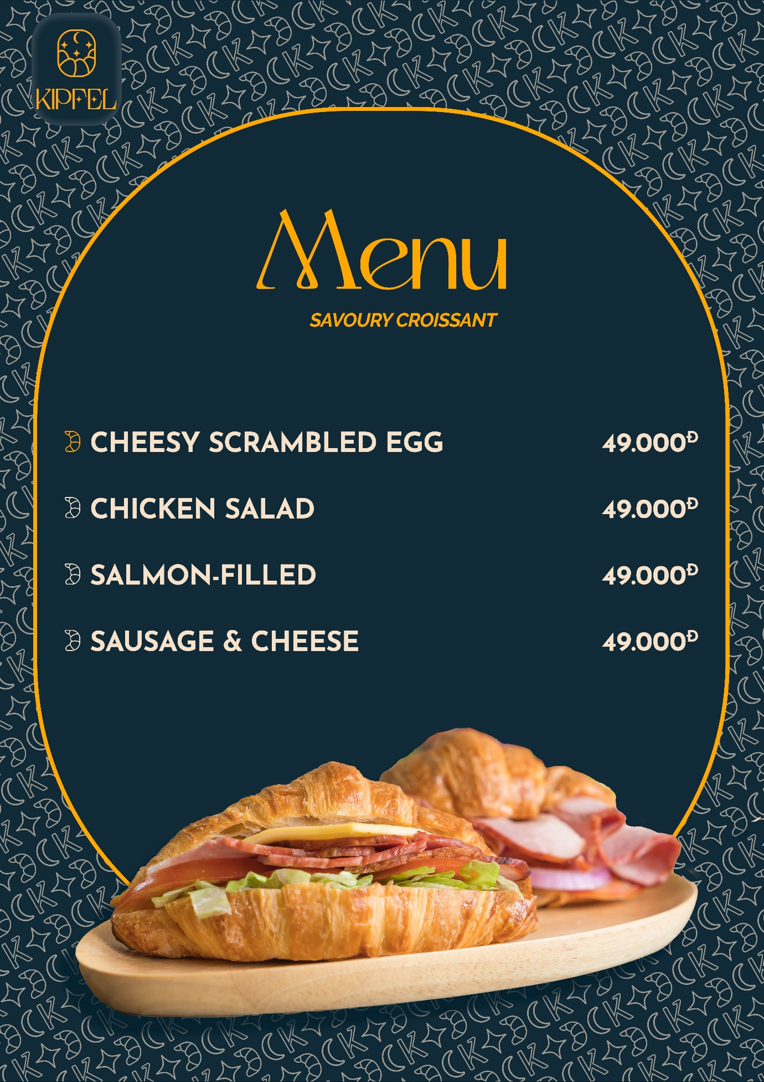

5 vòng tròn nhỏ đặt hình 5 cái bánh vào

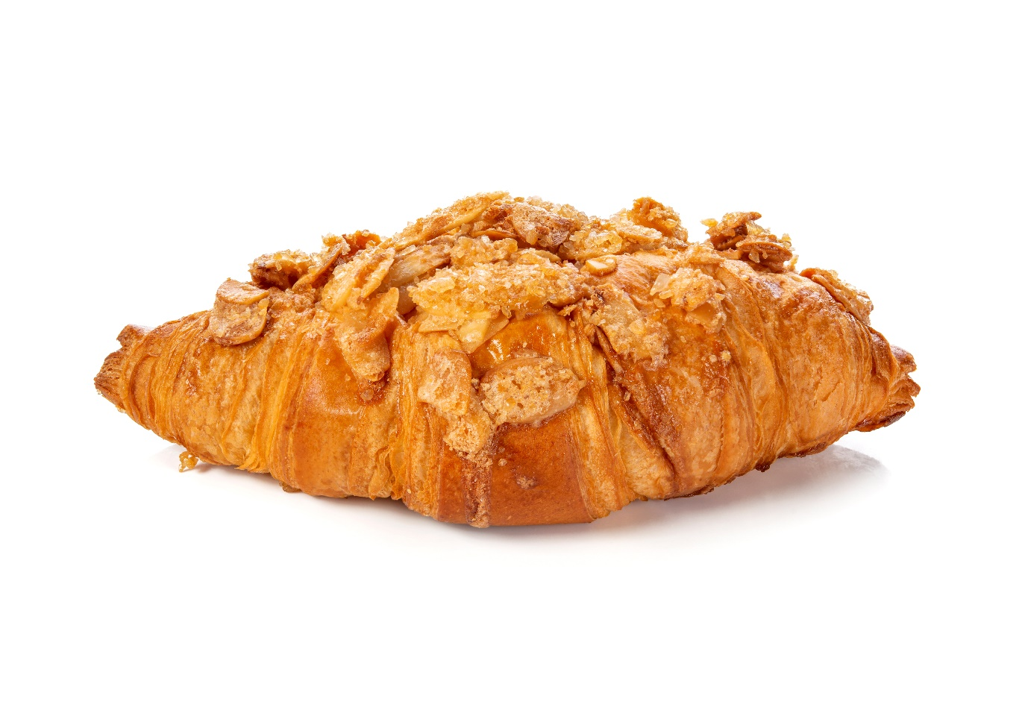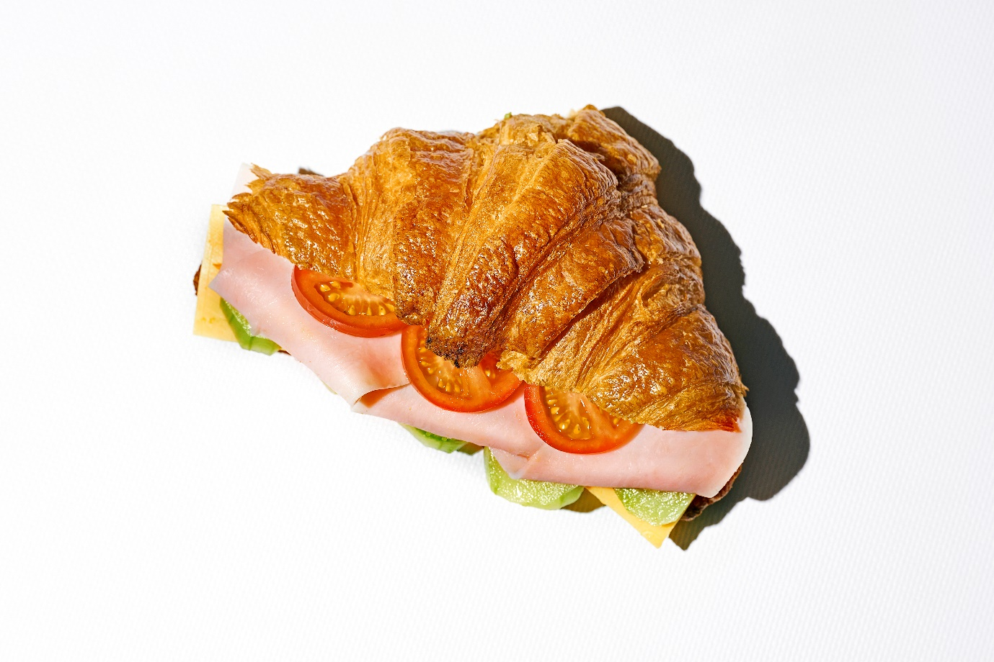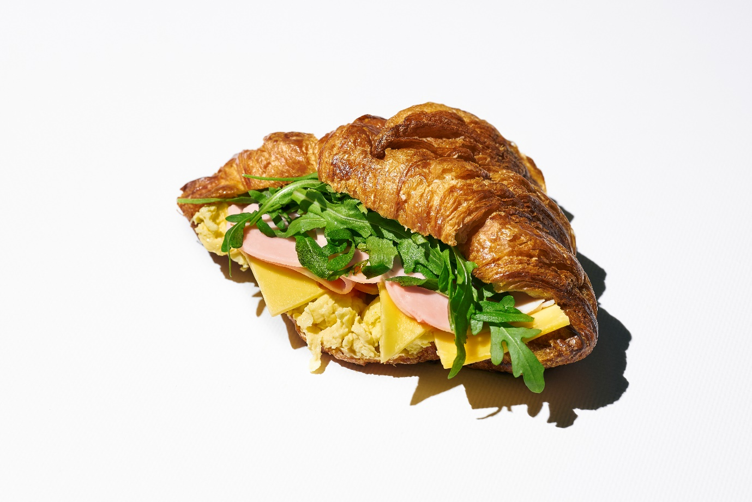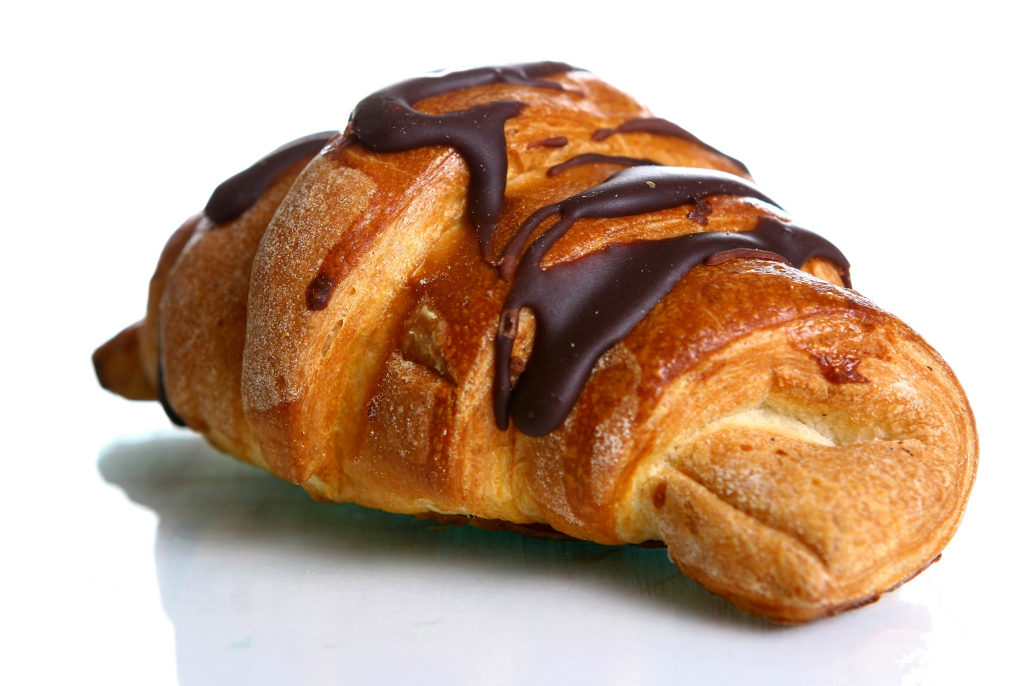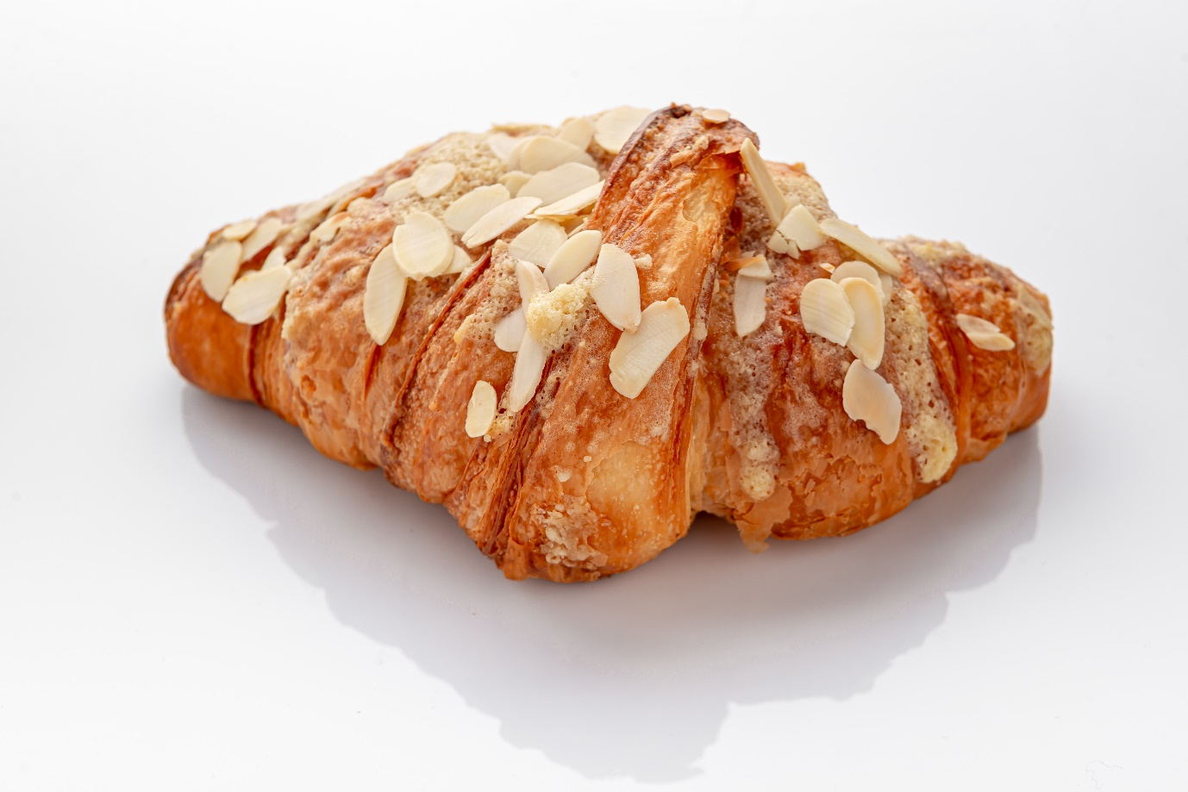

Cuối cùng

It is our pleasure to deliver to you our freshly baked croissant.  
Crunchy texture with a touch of delicate taste, the qualities will guarantee an irresistible sweet lust.  
Kipfel takes on the duty to serve you our most delicious crescent-shaped pastry.  
We are looking forward to your feedback.

Hình kế bên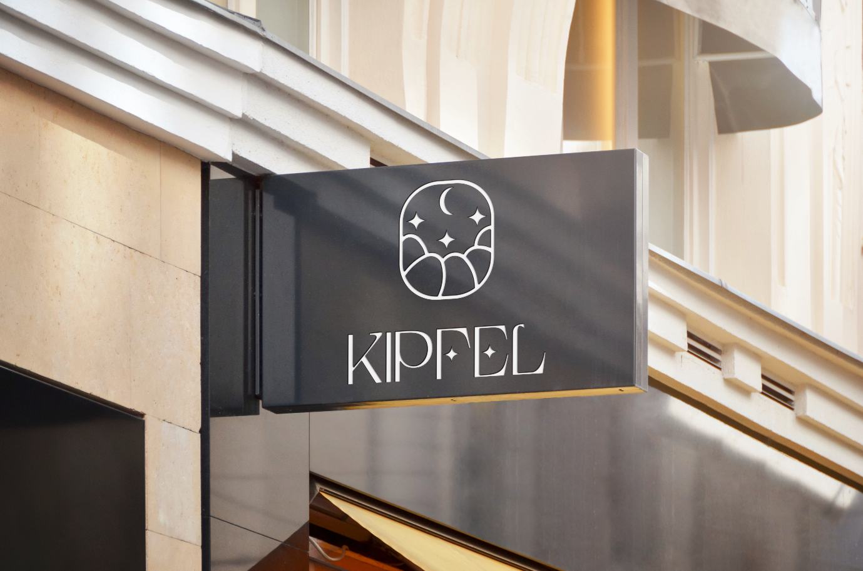

Cuối trang để thông tin :

* Phone: 0905157474
* Email: [info@kipfelhcm.com](mailto:info@kipfelhcm.com)
* Hotline: 1900 3338
* Address: 72 Le Thanh Ton, District 1, Ho Chi Minh City